https://netjs.blogspot.com/2018/08/spring-web-mvc-tutorial.html

What Is Spring Framework?
Spring is a light weight and open source framework created by Rod Johnsonin 2003. Spring is a complete and a modular framework, i mean spring framework can be used for all layer implementations for a real time application or spring can be used for the development of particular layer of a real time application unlike struts [ only for front end related ] and hibernate [ only for database related ], but with spring we can develop all layers
Spring framework is said to be a non-invasive means it doesn’t force a programmer to extend or implement their class from any predefined class or interface given by Spring API, in struts we used to extend Action Class right that’s why struts is said to be invasive
In case of struts framework, it will forces the programmer that, the programmer class must extend from the base class provided by struts API
Spring is light weight framework because of its POJO model
Spring Framework made J2EE application development little easier, by introducing POJO model

Spring having this much of demand because of the following 3 reasons….
- Simplicity
- Testability
- Loose Coupling
1. Simplicity
Spring framework is simple because as it is non-invasive, POJO and POJI model
2. Testability
Actually for writing the spring application, server [Container] is not mandatory, but for struts applications we need a server, and for EJB too. If we want to test the application it may need lot of changes in the source and each time we must restart the server to view the changes, which is little tedious and time taking but we can over come this in Spring, for testing spring application server is not mandatory spring has it own container to run the applications.
Spring can be used to develop any kind of java application, means we can develop starting from console application to enterprise level application
3. Loose Coupling
In spring objects are loosely coupled, this is the core concept of spring framework we will see in depth about this loose coupling and how its differ from tight coupling

Inversion Of Control (IOC) and Dependency Injection
These are the design patterns that are used to remove dependency from the programming code. They make the code easier to test and maintain. Let's understand this with the following code:
- class Employee{
- Address address;
- Employee(){
- address=new Address();
- }
- }

In such case, there is dependency between the Employee and Address (tight coupling). In the Inversion of Control scenario, we do this something like this:
- class Employee{
- Address address;
- Employee(Address address){
- this.address=address;
- }
- }
thus, IOC makes the code loosely coupled. In such case, there is no need to modify the code if our logic is moved to new environment.

In Spring framework, IOC container is responsible to inject the dependency. We provide metadata to the IOC container either by XML file or annotation.

Advantage of Dependency Injection
- makes the code loosely coupled so easy to maintain
- makes the code easy to test

IoC Container
The IoC container is responsible to instantiate, configure and assemble the objects. The IoC container gets informations from the XML file and works accordingly. The main tasks performed by IoC container are:
- to instantiate the application class
- to configure the object
- to assemble the dependencies between the objects
There are two types of IoC containers. They are:
- BeanFactory
- ApplicationContext

Difference between BeanFactory and the ApplicationContext
The org.springframework.beans.factory.BeanFactory and the org.springframework.context.ApplicationContext interfaces acts as the IoC container.
The ApplicationContext interface is built on top of the BeanFactory interface. It adds some extra functionality than BeanFactory such as simple integration with Spring's AOP, message resource handling (for I18N), event propagation, application layer specific context (e.g. WebApplicationContext) for web application. So it is better to use ApplicationContext than BeanFactory.

Dependency Injection in Spring
Dependency Injection (DI) is a design pattern that removes the dependency from the programming code so that it can be easy to manage and test the application. Dependency Injection makes our programming code loosely coupled.

Two ways to perform Dependency Injection in Spring framework
Spring framework provides two ways to inject dependency
- By Constructor: It is accomplished when the container invokes a class constructor with a number of arguments, each representing a dependency on other class.
- By Setter method: It is accomplished by the container calling setter methods on your beans after invoking a no-argument constructor or no-argument static factory method to instantiate your bean.
- Interface Injection (e.g. Avalon): Injection is done through an interface.

Note: Spring supports only Constructor and Setter Injection

What is the difference between constructor injection and setter injection?
 | Constructor Injection | Setter Injection
1) | No Partial Injection | Partial Injection
2) | Desn't override the setter property | Overrides the constructor property if both are defined.
3) | Creates new instance if any modification occurs | Doesn't create new instance if you change the property value
4) | Better for too many properties | Better for few properties.

Stereotype Annotations in Spring
The Four Types of Spring Stereotype Components and Their Purposes:
+------------+-----------------------------------------------------+
| Annotation | Meaning |
+------------+-----------------------------------------------------+
| @Component | generic stereotype for any Spring-managed component |
| @Repository| stereotype for persistence layer |
| @Service | stereotype for service layer |
| @Controller| stereotype for presentation layer (spring-mvc) |
+------------+-----------------------------------------------------+

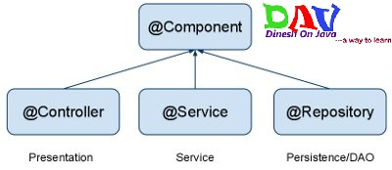

Autowiring in Spring
Autowiring feature of spring framework enables you to inject the object dependency implicitly. It internally uses setter or constructor injection.
Autowiring can't be used to inject primitive and string values. It works with reference only.

Advantage of Autowiring
It requires the less code because we don't need to write the code to inject the dependency explicitly.

Disadvantage of Autowiring
No control of programmer.
It can't be used for primitive and string values.

Autowiring Modes
There are many autowiring modes:
No. | Mode | Description
1) | no | this is the default mode, it means autowiring is not enabled.
2) | byName | injects the bean based on the property name. It uses setter method.
3) | byType | injects the bean based on the property type. It uses setter method.
4) | constructor | It injects the bean using constructor

What are the different bean scopes in spring?
There are 5 bean scopes in spring framework.
No. | Scope | Description
1) | singleton | The bean instance will be only once and same instance will be returned by the IOC container. It is the default scope.
2) | prototype | The bean instance will be created each time when requested.
3) | request | The bean instance will be created per HTTP request.
4) | session | The bean instance will be created per HTTP session.
5) | globalsession | The bean instance will be created per HTTP global session. It can be used in portlet context only.

Spring MVC Execution Flow Diagram, Spring MVC 3.2 Flow
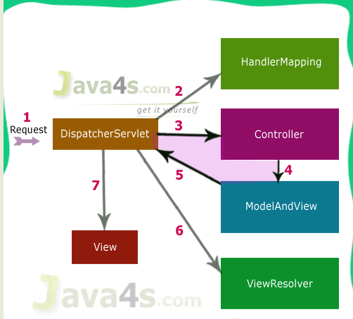

Spring MVC 3.2 Execution Flow
Step 1: First request will be received by DispatcherServlet
Step 2: DispatcherServlet will take the help of HandlerMapping and get to know the Controller class name associated with the given request
Step 3: So request transfer to the Controller, and then controller will process the request by executing appropriate methods and returns ModeAndView object (contains Model data and View name) back to the DispatcherServlet
Step 4: Now DispatcherServlet send the model object to the ViewResolver to get the actual view page
Step 5: Finally DispatcherServlet will pass the Model object to the View page to display the result

